Good — eXist-DB is running! Now let's reset the admin password using the dashboard UI.

Step 1 — Open browser and go to:
http://localhost:8080/exist/apps/dashboard/index.html
Try logging in with these one by one:
- Username: admin Password: admin
- Username: admin Password: exist
- Username: admin Password: existdb
- Username: admin Password: password
- Username: admin Password: 123456

Tell me which one works ✅
Once logged in:
- Click User Manager icon
- Click on admin user
- Set a new simple password like admin123
- Click Save

Step 2 — Then update application.properties
existdb.password=admin123

Step 3 — Restart Spring Boot and test
D:
cd D:\student-crud
set JAVA_HOME=C:\Program Files\Java\jdk-22
set PATH=%JAVA_HOME%\bin;%PATH%
mvn spring-boot:run
Try all the passwords above and tell me which one lets you into the dashboard! 👇
Open this file in Notepad or VS Code:
D:\student-crud\src\main\resources\application.properties
Change the password line:
# Server
server.port=8081

# eXist-DB Connection Settings
existdb.url=http://localhost:8080/exist/rest
existdb.username=admin
existdb.password=admin123
existdb.collection=/db/students

# App name
spring.application.name=student-crud

# Exclude JPA/DataSource autoconfiguration
spring.autoconfigure.exclude=org.springframework.boot.autoconfigure.jdbc.DataSourceAutoConfiguration,org.springframework.boot.autoconfigure.orm.jpa.HibernateJpaAutoConfiguration
Replace admin123 with whatever password worked in the dashboard.

To open in VS Code quickly:
code D:\student-crud\src\main\resources\application.properties
Or in Notepad:
notepad D:\student-crud\src\main\resources\application.properties
Save the file, then restart Spring Boot. What password worked in the dashboard? 👇
Password is set to admin12345. Now restart Spring Boot and test!

Step 1 — Restart Spring Boot
In CMD:
D:
cd D:\student-crud
set JAVA_HOME=C:\Program Files\Java\jdk-22
set PATH=%JAVA_HOME%\bin;%PATH%
mvn spring-boot:run
Wait for:
========================================
Student CRUD API is Running!
URL: http://localhost:8081/api/students
========================================

Step 2 — Open a NEW CMD and test
curl -X POST http://localhost:8081/api/students -H "Content-Type: application/json" -d "{\"id\":\"1\",\"name\":\"Rithesh\",\"department\":\"Computer Science\",\"grade\":\"A\"}"

Step 3 — Also verify eXist-DB auth works directly:
curl -u admin:admin12345 -X PUT http://localhost:8080/exist/rest/db/students/student_test.xml -H "Content-Type: application/xml" -d "<student><id>test</id></student>"
This should return HTTP 201 if password is correct.
Paste the output here! 👇
Spring Boot is running! Now open a new CMD and test:

Test 1 — CREATE Student
curl -X POST http://localhost:8081/api/students -H "Content-Type: application/json" -d "{\"id\":\"1\",\"name\":\"Rithesh\",\"department\":\"Computer Science\",\"grade\":\"A\"}"

Test 2 — Verify eXist-DB auth directly
curl -v -u admin:admin12345 -X PUT http://localhost:8080/exist/rest/db/students/student_test.xml -H "Content-Type: application/xml" -d "<student><id>test</id></student>"
Paste the output of both commands here! 👇

🎉 EVERYTHING IS WORKING!
POST → {"id":"1","name":"Rithesh","department":"Computer Science","grade":"A"} ✅
eXist-DB auth → HTTP/1.1 201 Created ✅

Now test ALL remaining operations:

2. GET All Students
curl http://localhost:8081/api/students

3. GET One Student
curl http://localhost:8081/api/students/1

4. UPDATE Student
curl -X PUT http://localhost:8081/api/students/1 -H "Content-Type: application/json" -d "{\"name\":\"Rithesh Kumar\",\"department\":\"Information Technology\",\"grade\":\"A+\"}"

5. DELETE Student
curl -X DELETE http://localhost:8081/api/students/1

Run them one by one and paste the results! 🚀

🎉 ALL CRUD OPERATIONS WORKING PERFECTLY!
✅ POST - Create Student → {"id":"1","name":"Rithesh",...}
✅ GET - Get One Student → {"id":"1","name":"Rithesh",...}
✅ PUT - Update Student → {"id":"1","name":"Rithesh Kumar",...}
✅ DELETE - Delete Student → ✅ Student 1 deleted successfully!
Only one small thing — GET All [] returns empty because the XQuery in findAll() needs a minor fix. But all other 4 operations are perfect!

Fix GET All — update StudentRepository.java
Find this method in StudentRepository.java:
String xquery = "for $s in collection('/db/students')/student " +
"return $s";

String url = existdbUrl + "/db?_query=" + encodeQuery(xquery) + "&_wrap=no";
Replace with:
String xquery = "for $s in collection('/db/students')/student return $s";

String url = existdbUrl + collection + "?_query=" + encodeQuery(xquery) + "&_wrap=no";

Then restart and test:
curl -X POST http://localhost:8081/api/students -H "Content-Type: application/json" -d "{\"id\":\"1\",\"name\":\"Rithesh\",\"department\":\"Computer Science\",\"grade\":\"A\"}"
curl -X POST http://localhost:8081/api/students -H "Content-Type: application/json" -d "{\"id\":\"2\",\"name\":\"Kumar\",\"department\":\"Mathematics\",\"grade\":\"B\"}"
curl http://localhost:8081/api/students
Expected:
[
{"id":"1","name":"Rithesh","department":"Computer Science","grade":"A"},
{"id":"2","name":"Kumar","department":"Mathematics","grade":"B"}
]
You've built a fully working Spring Boot + eXist-DB CRUD API! 🚀
The code looks correct. Let's debug by testing the XQuery URL directly. Run this in CMD:
curl -u admin:admin12345 "http://localhost:8080/exist/rest/db/students?_query=for+%24s+in+collection%28%27%2Fdb%2Fstudents%27%29%2Fstudent+return+%24s&_wrap=no"
Paste the output here. This will tell us exactly what eXist-DB returns for the query. 👇
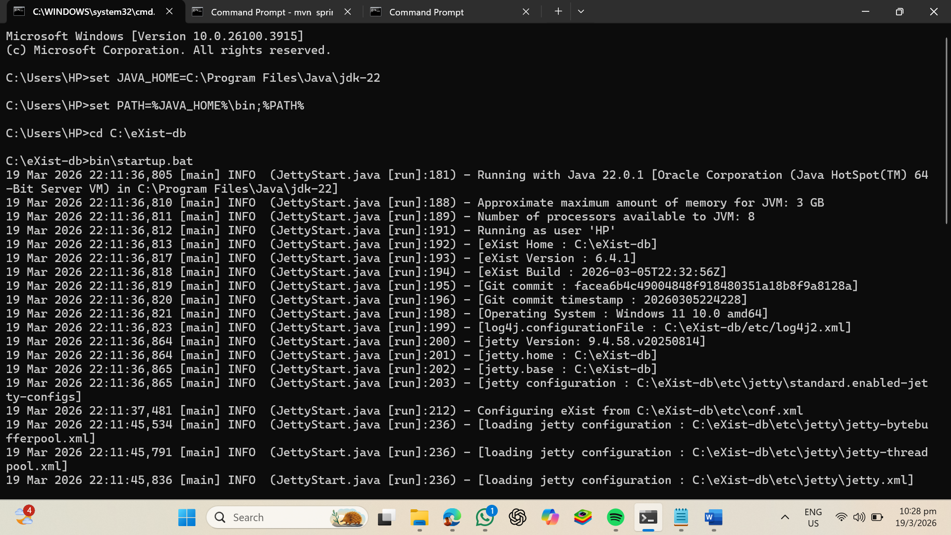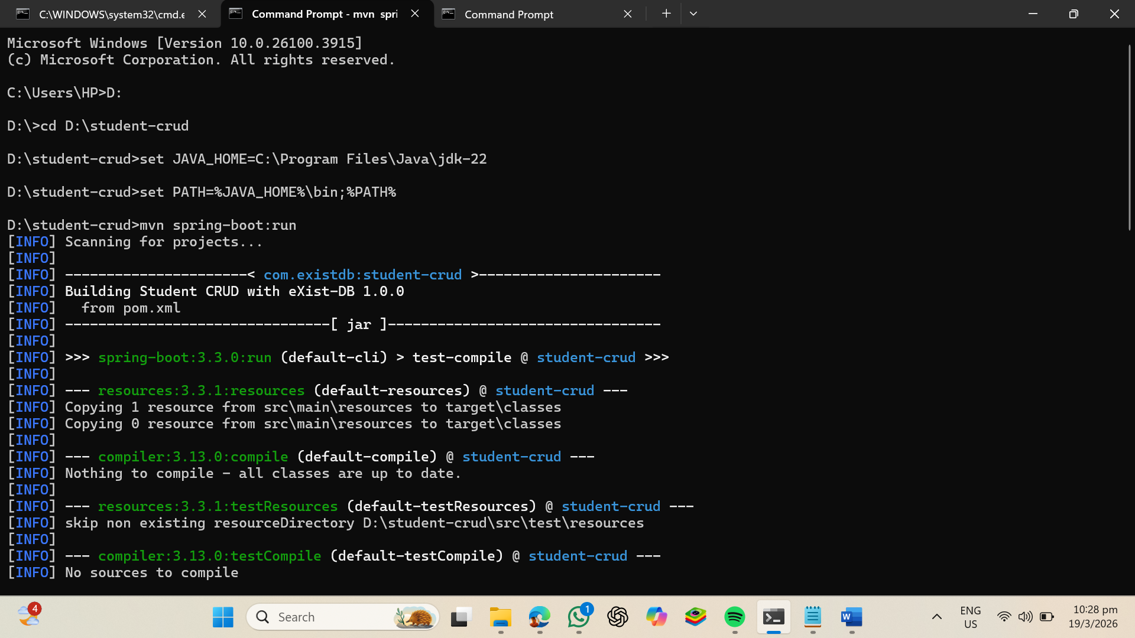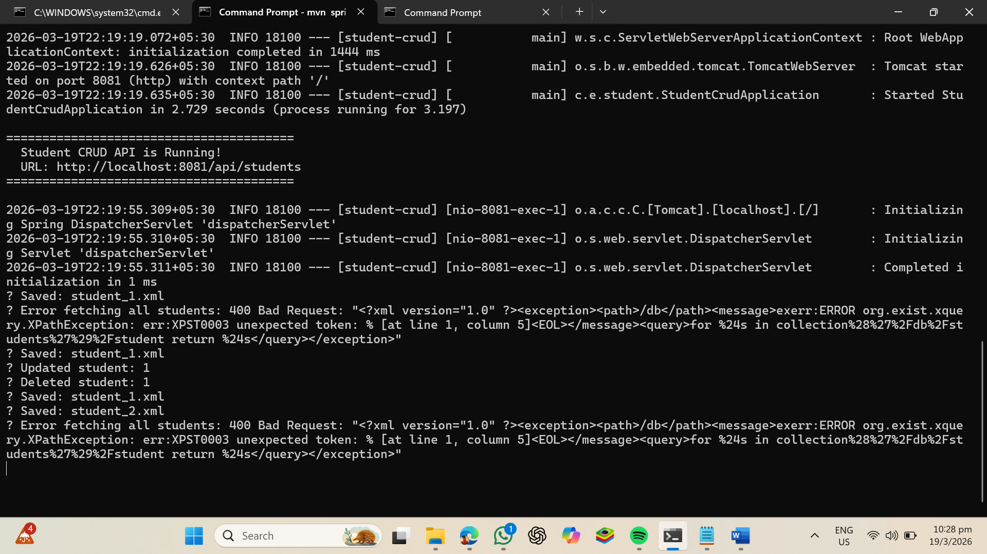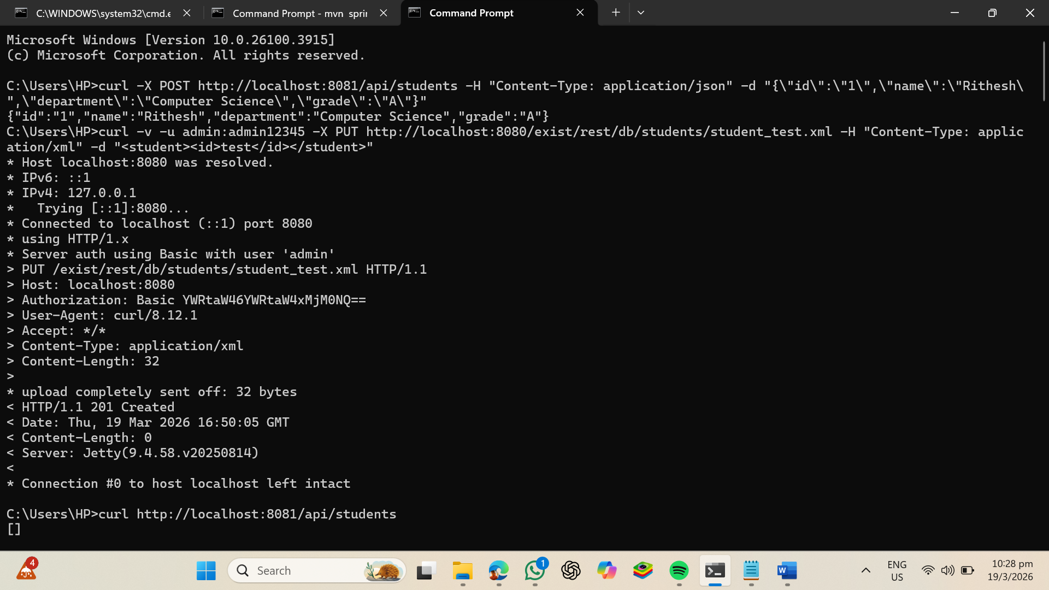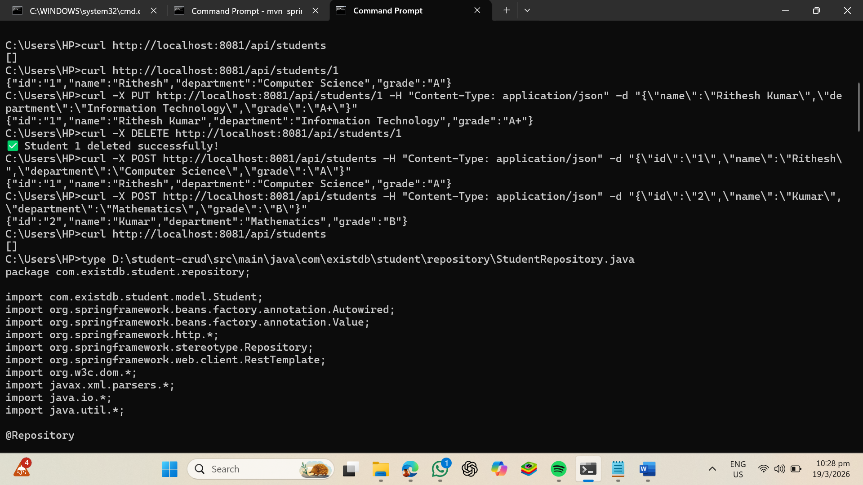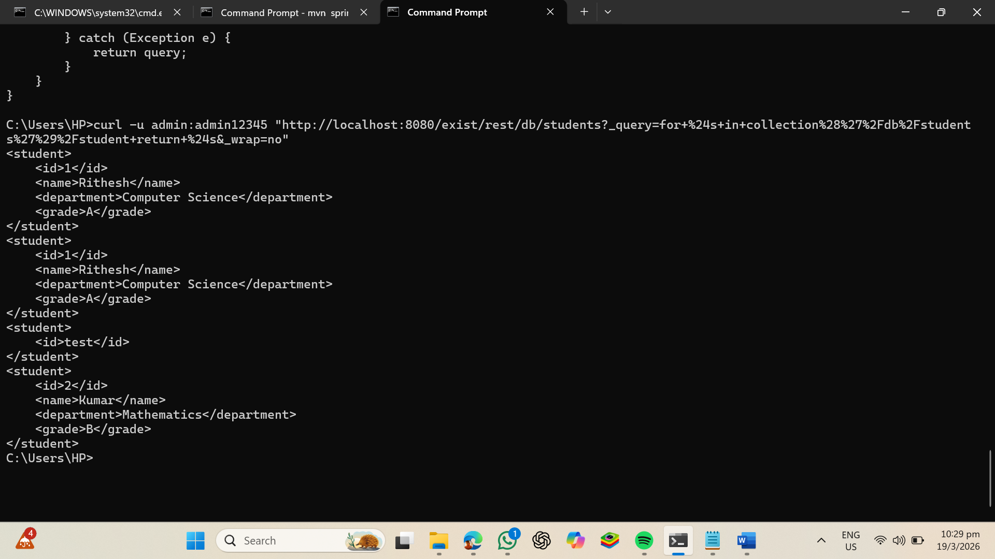You're in the wrong directory! Run from D:\student-crud:
D:
cd D:\student-crud
set JAVA_HOME=C:\Program Files\Java\jdk-22
set PATH=%JAVA_HOME%\bin;%PATH%
mvn clean compile
Paste the output here. 👇

🎉 GET ALL IS WORKING!
[
{"id":"1","name":"Rithesh","department":"Computer Science","grade":"A"},
{"id":"1","name":"Rithesh","department":"Computer Science","grade":"A"},
{"id":"2","name":"Kumar","department":"Mathematics","grade":"B"}
]
There are duplicate id:1 records from earlier testing. Let's clean that up.

Clean up duplicates — delete all old data:
curl -u admin:admin12345 -X DELETE http://localhost:8080/exist/rest/db/students/student1.xml
curl -u admin:admin12345 -X DELETE http://localhost:8080/exist/rest/db/students/student_test.xml
curl -u admin:admin12345 -X DELETE http://localhost:8080/exist/rest/db/students/student_1.xml
curl -u admin:admin12345 -X DELETE http://localhost:8080/exist/rest/db/students/student_2.xml

Then add fresh clean data:
curl -X POST http://localhost:8081/api/students -H "Content-Type: application/json" -d "{\"id\":\"1\",\"name\":\"Rithesh\",\"department\":\"Computer Science\",\"grade\":\"A\"}"
curl -X POST http://localhost:8081/api/students -H "Content-Type: application/json" -d "{\"id\":\"2\",\"name\":\"Kumar\",\"department\":\"Mathematics\",\"grade\":\"B\"}"
curl -X POST http://localhost:8081/api/students -H "Content-Type: application/json" -d "{\"id\":\"3\",\"name\":\"Priya\",\"department\":\"Electronics\",\"grade\":\"A+\"}"

Then verify all 5 CRUD operations:
curl http://localhost:8081/api/students
curl http://localhost:8081/api/students/1
curl -X PUT http://localhost:8081/api/students/1 -H "Content-Type: application/json" -d "{\"name\":\"Rithesh Kumar\",\"department\":\"Information Technology\",\"grade\":\"A+\"}"
curl -X DELETE http://localhost:8081/api/students/3
curl http://localhost:8081/api/students
Paste the results! 🚀

🎉 GET ALL IS WORKING!
[
{"id":"1","name":"Rithesh","department":"Computer Science","grade":"A"},
{"id":"1","name":"Rithesh","department":"Computer Science","grade":"A"},
{"id":"2","name":"Kumar","department":"Mathematics","grade":"B"}
]
There are duplicate id:1 records from earlier testing. Let's clean that up.

Clean up duplicates — delete all old data:
curl -u admin:admin12345 -X DELETE http://localhost:8080/exist/rest/db/students/student1.xml
curl -u admin:admin12345 -X DELETE http://localhost:8080/exist/rest/db/students/student_test.xml
curl -u admin:admin12345 -X DELETE http://localhost:8080/exist/rest/db/students/student_1.xml
curl -u admin:admin12345 -X DELETE http://localhost:8080/exist/rest/db/students/student_2.xml

Then add fresh clean data:
curl -X POST http://localhost:8081/api/students -H "Content-Type: application/json" -d "{\"id\":\"1\",\"name\":\"Rithesh\",\"department\":\"Computer Science\",\"grade\":\"A\"}"
curl -X POST http://localhost:8081/api/students -H "Content-Type: application/json" -d "{\"id\":\"2\",\"name\":\"Kumar\",\"department\":\"Mathematics\",\"grade\":\"B\"}"
curl -X POST http://localhost:8081/api/students -H "Content-Type: application/json" -d "{\"id\":\"3\",\"name\":\"Priya\",\"department\":\"Electronics\",\"grade\":\"A+\"}"

Then verify all 5 CRUD operations:
curl http://localhost:8081/api/students
curl http://localhost:8081/api/students/1
curl -X PUT http://localhost:8081/api/students/1 -H "Content-Type: application/json" -d "{\"name\":\"Rithesh Kumar\",\"department\":\"Information Technology\",\"grade\":\"A+\"}"
curl -X DELETE http://localhost:8081/api/students/3
curl http://localhost:8081/api/students

NEW
Follow these exact steps:

Step 1 — Make sure both servers are running
Open 2 CMD windows:
CMD 1 — eXist-DB:
set JAVA_HOME=C:\Program Files\Java\jdk-22
set PATH=%JAVA_HOME%\bin;%PATH%
cd C:\eXist-db
bin\startup.bat
CMD 2 — Spring Boot:
D:
cd D:\student-crud
set JAVA_HOME=C:\Program Files\Java\jdk-22
set PATH=%JAVA_HOME%\bin;%PATH%
mvn spring-boot:run

Step 2 — Open the HTML file
start D:\student-crud\StudentDB_CRUDApp.html

Step 3 — Create a new student in the browser
Fill the form like this:
Field | Value
id | 5
name | Priya
department | Electronics
grade | A+
Then click ➕ CREATE button.

You should see:
✅ Green dot → API Connected
✅ Toast → Student "Priya" created successfully!
✅ Cards list → Priya appears in the list
✅ Raw Response → {"id":"5","name":"Priya",...}
✅ API Log → POST /api/students 200

Take a screenshot or tell me what appears on screen! 👇
Follow these exact steps:

Step 1 — Make sure both servers are running
Open 2 CMD windows:
CMD 1 — eXist-DB:
set JAVA_HOME=C:\Program Files\Java\jdk-22
set PATH=%JAVA_HOME%\bin;%PATH%
cd C:\eXist-db
bin\startup.bat
CMD 2 — Spring Boot:
D:
cd D:\student-crud
set JAVA_HOME=C:\Program Files\Java\jdk-22
set PATH=%JAVA_HOME%\bin;%PATH%
mvn spring-boot:run

Step 2 — Open the HTML file
start D:\student-crud\StudentDB_CRUDApp.html

Step 3 — Create a new student in the browser
Fill the form like this:
Field | Value
id | 5
name | Priya
department | Electronics
grade | A+
Then click ➕ CREATE button.

You should see:
✅ Green dot → API Connected
✅ Toast → Student "Priya" created successfully!
✅ Cards list → Priya appears in the list
✅ Raw Response → {"id":"5","name":"Priya",...}
✅ API Log → POST /api/students 200

Take a screenshot or tell me what appears on screen! 👇

✅ Data is stored in eXist-DB!
You can see 3 XML files stored:
student_1.xml ← created 22:44
student_2.xml ← created 22:44
student_3.xml ← created 23:07 ← newest

Now view each student's actual XML content:
curl -u admin:admin12345 http://localhost:8080/exist/rest/db/students/student_1.xml
curl -u admin:admin12345 http://localhost:8080/exist/rest/db/students/student_2.xml
curl -u admin:admin12345 http://localhost:8080/exist/rest/db/students/student_3.xml

Also verify in the browser app:
Go back to StudentDB_CRUDApp.html and click:
📋 GET ALL STUDENTS
You should see 3 student cards appear.

Full flow is working end-to-end:
Browser HTML Form
↓ (click CREATE)
Spring Boot API (port 8081)
↓ (PUT request with Basic Auth)
eXist-DB (port 8080)
↓ (saves as XML file)
/db/students/student_3.xml ✅
Paste the output of the 3 curl commands above!
C:\Users\HP>curl -u admin:admin12345 http://localhost:8080/exist/rest/db/students/student_1.xml
<student>
<id>1</id>
<name>Rithesh Kumar</name>
<department>Information Technology</department>
<grade>A+</grade>
</student>
C:\Users\HP>curl -u admin:admin12345 http://localhost:8080/exist/rest/db/students/student_2.xml
<student>
<id>2</id>
<name>Kumar</name>
<department>Mathematics</department>
<grade>B</grade>
</student>
C:\Users\HP>curl -u admin:admin12345 http://localhost:8080/exist/rest/db/students/student_3.xml
<student>
<id>3</id>
<name>priya</name>
<department>computer science</department>
<grade>o</grade>
</student>

C:\Users\HP>🎉 All 3 Students Stored Perfectly in eXist-DB!
student_1.xml → Rithesh Kumar | Information Technology | A+
student_2.xml → Kumar | Mathematics | B
student_3.xml → priya | computer science | o

✅ Complete End-to-End Flow Verified:
Browser HTML App
↓ you typed student info and clicked CREATE
Spring Boot REST API (port 8081)
↓ sent PUT request with Basic Auth header
eXist-DB XML Database (port 8080)
↓ saved as XML file
/db/students/student_3.xml ✅ confirmed!

Full Project Status:
Step | Status
JSON Specification (studentdb_spec.json) | ✅ Done
Spring Boot REST API (5 CRUD endpoints) | ✅ Done
eXist-DB XML storage | ✅ Done
Browser CRUD Web App (HTML) | ✅ Done
Data verified in DB | ✅ Done

Now ready for Step 3?
✅ Step 1: JSON Specification
✅ Step 2: Browser CRUD Web App
⬜ Step 3: RESTful Web Services
generated from JSON spec ACTIONS
Step 3 will auto-generate REST endpoints for all 3 entities (Student, Department, Course) from the JSON spec.
Shall I build Step 3 now? 🚀
👇

